**Home Improvement Factory**

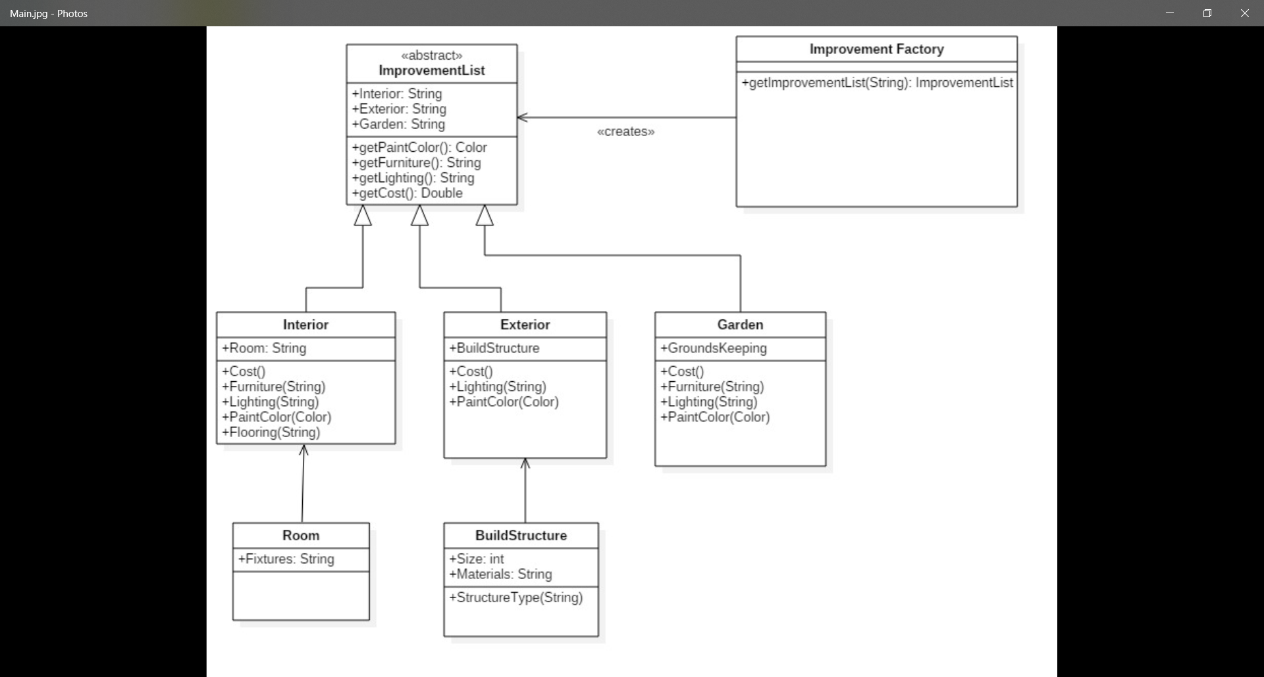

**Interior –** Would be a subclass of ImprovementList. In this class you could choose which room to improve from its subclass **Room**. You would also see the cost of the improvement by calling the Cost method. And also add furniture, lighting, flooring and paint colour by calling the appropriate method. In the sub class **Room,** you could add fixtures for example, if the room is a toilet the types of fixtures would be toilet, hand basin etc. You could also use constructor overloading to set individual rooms flooring, lighting and paint colour etc.

**Exterior –** Would also be a sub class of ImprovementList. In this class you could build structures such as extensions, attic conversions etc from the subclass BuildStructure. Similarly, to the Interior class you could see the cost, add exterior lighting and paint. In the BuildStructure class set the materials to be used in the build and its size.

**Garden –** Is also a sub class of ImprovementList. In this class you can use the groundsKeeping method for tasks such as gardening, washing windows/driveways, clearing gutters etc. Just like with the Interior and Exterior classes you can see the cost, add garden furniture, lightening and paint colour for garden fences/sheds etc.